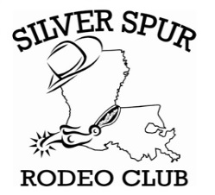
2017 Silver Spur Rodeo Club
Membership Form

Name_____________________________________________________________

Birthday__________________________________________________________

Address___________________________________________________________

City___________________ State______________ Zip___________________

Cell Phone:________________________________________________________

Email:____________________________________________________________

Additional Family Members

Name Birthday

___________________________________ _______________________

___________________________________ _______________________

___________________________________ _______________________

___________________________________ _______________________

___________________________________ _______________________

In consideration of accepting this, i the undersigned; intending to be legally for myself, my heirs, executors and administrators, waive and release all rights and claims for damages i may have against silver spur rodeo club, west cal arena and any other person or entity associated with this event and their representatives, successors, and assign for any and all injuries suffered by me in said event(s). Further, i hereby grant full permission to the ssrc publicity chairperson(s) to use photographs, video tapes, motion pictures, recordings, or any other record of this event for any purpose to enhance the silver spur rodeo club.

Signature_________________________________ Date__________________
Parent’s signature is required for contestants under 18 years of age

Type of Membership
Single-($35) _______ Family-($60) _______

Received By:____________________________________________

WARNING:

Under Louisiana law, an equine activity sponsor or equine professional is not liable for an injury to or the death of a participant in equine activities resulting from the inherent risks of equine activities, pursuant to R.S. 9:2795.3.

