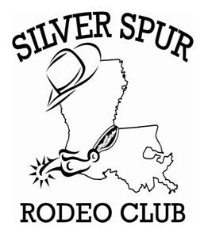

T-Shirt
Sponsorship
Letter Request

Silver Spur Rodeo Club Sponsorship Business Information Sheet
Due by February 17th, 2017

Business Name: ______________________________________________________________________
Contact Name: _____________________________________
Phone Number: _____________________________________
Business Address: _____________________________________________________________________
Contact Email: ___________________________________________________________________________

We are inviting you to consider becoming a sponsor of our 2017 Rodeo Season.

Thank you for your consideration of this request for your support. We have several levels and options that you can choose from to show your support. All sponsors will receive a spot on the back of the t-shirt. The size of the logo will be determined by the level of the sponsorship. Levels are listed below. If you have any questions, please contact Ricky Jordan at 337-263-0036, Stephanie Caswell 337-842-8287,Or Trudi Buckley at 337-540-6280

To show my support for SSRC’s 2017 Year, I have attached my check made payable to SSRC in the amount of:

_____Gold Sponsorship ($100) (Size approximately 2-3 inches) Company Name, # and LOGO

_____Silver Sponsorship ($75) (Size approximately 1-2 inches) Company Name and Phone #

_____Bronze Sponsorship ($50) (Size 1/2 inch—1 inch) Company Name Only

_____Other Sponsorship Levels Available for special request

I understand that by my sponsorship, my business name will be printed on the back of the 2017 SSRC t-shirt.

